Cheerleading Tryouts

Mandatory Informational Meeting

August 28th – 4:00-5:30pm

Williams Hall – Room 317

Tryouts

August 29th - 10:00am-3:00pm
-and-
August 30th – 10:00am-1:00pm
Hill Center Gymnastics Room

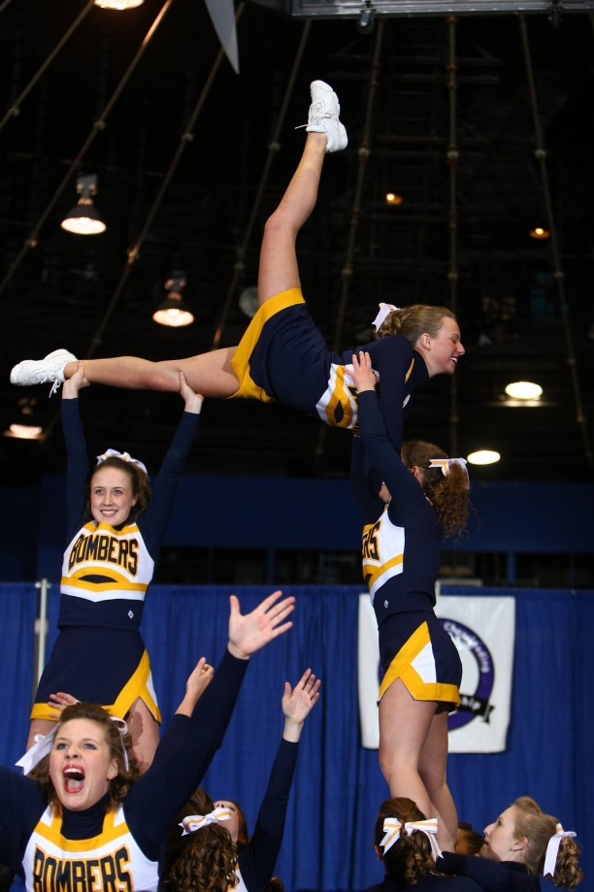
Details:
Tryouts will be held over a two day span. The first day the material will be taught and perfected. The second day the material will be reviewed and the tryout will take place.

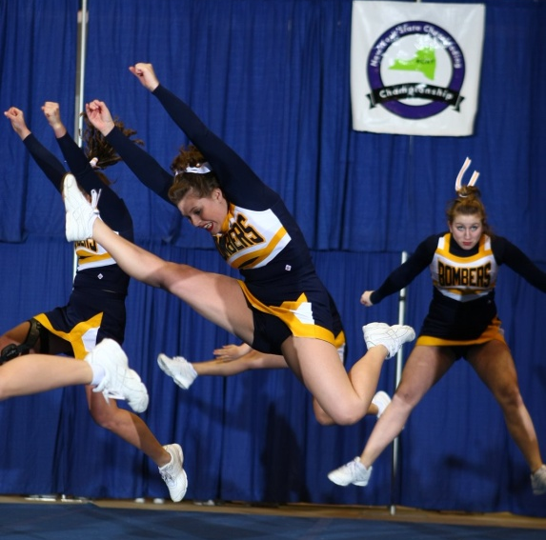

Any questions? Contact Jessica Sharkey at president@iccheer.com
For more details, visit http://www.iccheer.com
Sponsored by IC Recreational Sports

